
Online edition of India's National Newspaper
Tuesday, Dec 15, 2009
Music Season
The Chennai December Festival
Date:15/12/2009 URL: 2009/12/15/stories/2009121550090600.htm
The silken effect
S. SIVAKUMAR
If Rajaram's flute recital exemplified the young artist's absorbing skill, Maharajapuram Ganesh Viswanathan's voice was appealing in its serenity
This year, Rajaram and Ganesh Viswanathan, two enthusiastic blossoming performers, participated in theconcert series that was held at Jaigopal Garodia Vidyalaya, Anna Nagar, under the auspices of Shi-ba Sangeetha Sabha.

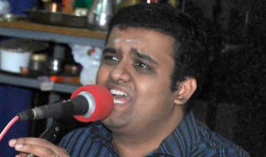
Ganesh Viswanathan
One had to marvel at the sheer power of Maharajapuram Ganesh Viswanathan's voice. His eduppu had a natural serenity, which suffused the songs with bhava. His alapanas for Hindolam (‘Manasuloni' -Tyagaraja) and Dharmavathi (‘Bangaru'- Annamayya) were marked by an artistic approach, which saw the gradual unfolding of the many aspects of the ragas. They were modelled on manodharmic style that followed the tradition he is heir to.
Two songs of Tyagaraja – ‘Ra Ra Thodu Ra Ra' (Atana) and ‘Dasaratha Nandana' (Asaveri), Santhanam' s favourites -- had the audience feeling immense satisfaction as they seemed to take them to a past era.
An afterthought – Ganesh should stay away from the intoxication he derives from his nuances (nelivu-sulivu) as the tendency leaves certain words in the lyrics unintelligible.
His brigas also need to journey alongside the lyrics so as to capture the full import of the kritis. His swara-springs were imaginatively worked out. It is strange that neither artist sang a niraval.
Sundareswaran (violin) and Thanjavur Kumar (mridangam) -- senior vidwans -- were the accompanists for both the artists. They exercised moderation and thereby helped the audience focus their attention on the up and coming performers. The violinist's alapanas had glimpses of bow and playing techniques that were carried out without overdoing to the many swaraprastharams. Kumar intelligently adjusted his style.
He made his playing compatible with that of the main artistes and his style for the flautist was different from the playing he adopted for the vocalist. He restricted himself to two compact thanis of quality.
© Copyright 2000 - 2009 The Hindu

